Government and Non-Government Sponsored Loan Forgiveness Plans for Public Interest Lawyers in the United States

Photo labeled for non-commercial reuse at https://i.ytimg.com/vi/vyG0_dMJr_8/maxresdefault.jpg

It a common rhetoric that you hear walking around the halls of major U.S. Law Schools: “I was hoping to pursue a career in public interest, but I simply have too many loans.” These days many public service minded law school graduates in the United States simply can’t afford to pursue the jobs they desire because of crippling student loan debt. Today’s U.S. law graduates are often plagued with law school debt ranging from upwards of $80,000 (∼95,000,000 KRW) upon their graduation, which can then require payments of more than $900 (∼1,000,000 KRW) a month for the next ten years. In 2012 the average law graduate’s debt was $140,000 (∼160,000,000 KRW), 59% higher than just eight years earlier. With the average starting salary for lawyers in the public interest sector hovering around $47,000 (∼56,000,000 KRW), most students are forced to switch to higher profit yielding careers in the private and corporate sectors.
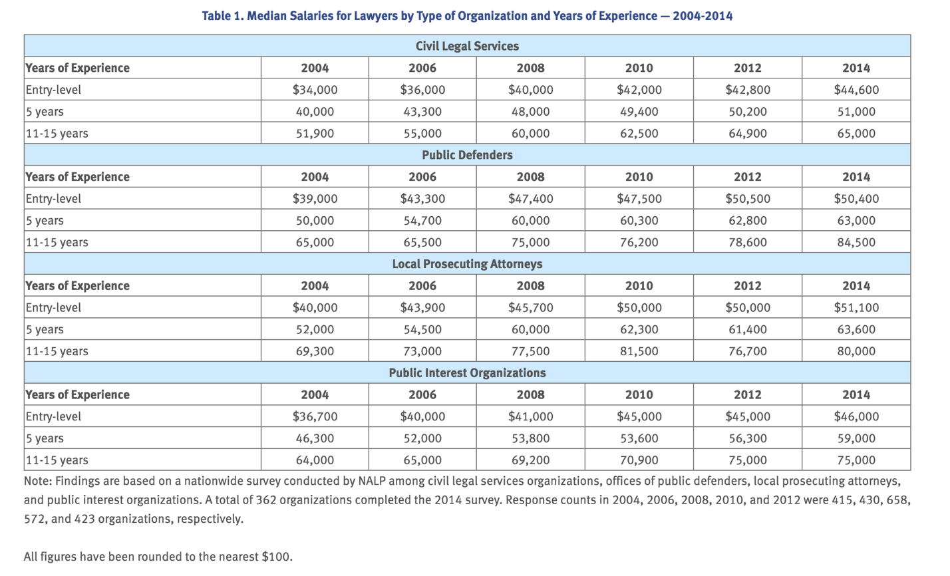
Source: National Association for Law Placement

In lieu of this situation, the American Bar Association (ABA), the U.S. Department of Education, local state governments, and even US law schools themselves have begun to introduce a variety of loan repayment assistance programs (“LRAPs”). These LRAPs were launched as an attempt to mitigate debt or income-based fears as well as enable a greater portion of students to pursue legal careers in the public service sector. LRAPs provide loan forgiveness, lower interest rates on loans, and deferment on loan repayments on law school loans for graduates entering law-related public interest employment. Some of the most notable forms of LRAPs include:

The Federal Public Service Loan Forgiveness Program (PSLF) – Founded in 2007, PSLF is a federal program designed to forgive student loan debt for employees of certain public and nonprofit jobs. Students are required to enroll in 10-year payment plans (designed to be affordable and usually based on both the amount of debt a student faces out of school as well as the salary of their new employment) and qualified students will, after ten years, have the remainder of their loans forgiven. Qualifying organizations include government organizations at any level (federal, state, local, or tribal) and not-for-profit organizations.

Income-Based Repayment (IBR) – IBR allows lawyers to keep their payments low until their loans are eventually forgiven. Participants who qualify generally pay no more than 15% of their discretionary income (anything you earn above the national poverty level, currently $11,490 (∼14,000,000 KRW)) towards their student loans. After 25 years of payment the outstanding balance will be forgiven. IBR is available to all types of employment, not just limited to the legal field.

Law School LRAPs – Over one hundred US law schools administer their own loan repayment assistance programs. These schools provide financial aid to law school graduates working in the public interest sector, government, or other qualifying low-paying fields. Typically, these programs have salary requirements, such as earning $75,000 (∼88,000,000KRW) or less per year. A full list of participating law schools can be found here.

Department of Justice (DOJ) Attorney Student Loan Repayment Program (ASLRP) – The DOJ offers their ASLRP program as a way to recruit and retain lawyers in the field. Every spring the government agency opens up applications to current employees and eligible candidates can receive up to $60,000 (∼71,000,000 KRW) in assistance.

John R. Justice Student Loan Repayment Program – This program provides up to $60,000 (∼71,000,000 KRW) in assistance to lawyers working as public defenders, a notoriously underpaid legal position in the United States. Funds are allocated annually from the Bureau of Justice Assistance and are awarded and administered by designated state agencies. Candidates must be employed as a public defender for at least three years.

After looking at these various programs, it might seem difficult to decipher what exactly qualifies as a public interest career. In 2007, U.S. Congress passed the College Cost Reduction and Access Act (two other provisions of the law established the PSLF and IBR programs listed above) and in doing so created a general definition of LRAP eligible public service. This definition serves as a benchmark for most LRAPs today. The College Cost Reduction and Access Act defines public interest work as employment by any level of the American government (federal, state, local or tribal) as well as employment by any organization that is deemed tax-exempt (status given to non-profit and charitable organizations) by the United States tax code. Employment must also be full-time with a minimum workload of 30 hours per-week.

Specific data in terms of the implementation of and number of students enrolled in LRAPS are quite hard to come by. This is in part because many law schools and other state based LRAPs often don’t publically release such statistics due to privacy concerns. Also the fact that LRAPs are relatively new means accumulating concrete evidence as to their effectiveness is rather difficult. That being said, recent research does suggest that the availability of LRAPs has become an important factor to pursue public interest employment after law school.

In my opinion, as a current law student myself, I feel there is a cultural shift currently making its way through law schools in the United States. Despite the increase in competition for fewer jobs, large salary disparities, and increased debt; the existence of LRAP programs and the fact that many accredited U.S. law schools now employ their own public-interest focused career centers have greatly advanced the opportunities for American public interest work. Additionally, improved media-capabilities that better showcase dire aspects within the criminal justice system in addition to greater awareness amongst the legal community of what a special privilege it is to practice law has also encouraged more and more young law graduates to make efforts towards working in these legal fields. With this in mind, I feel it is important that the relevant authorities continue to promote LRAPs so that financial obstacles such as student loan debt not jeopardize the unique opportunity for highly trained legal minds to invest their acquired skills back into the community.

American Bar Association “Loan Forgiveness” Available at http://www.americanbar.org/groups/government_public/pages/loan.html
“The Law School Debt Crisis” The New York Times, October 24, 2015. Available at http://www.nytimes.com/2015/10/25/opinion/sunday/the-law-school-debt-crisis.html?_r=0
Internal Revenue Service (IRS). “Exemption Requirements – 501(c)(3) Organizations” Available at https://www.irs.gov/charities-non-profits/charitable-organizations/exemption-requirements-section-501-c-3-organizations
Definitions, Sec. 455 (20 U.S.C. 1087e)
Alan K. Chen & Scott L. Cummings. “Public Interest Lawyering: A Contemporary Perspective” Wolters Kluwer (2012).

